**PROJECT REPORT**

**ON**

Wind power generation system using MATLAB & Simulink

Project Report submitted for the requirement for the degree of Bachelor of Technology in Electrical Engineering from Department of Electrical Engineering, Heritage Institute of Technology, Maulana Abul Kalam Azad University of Technology, West Bengal.

Submitted By:

**Kallol Ghosh - 1759052 (12617016020)**

**Sayandip Paul - 1759081 (12617006039)**

**Ayus Sukla - 1759012 (12617016012)**

**Sauvik Sarkar – 1759018 (12617016044)**

**Sairath Das – 1759023 (12617016038)**

**Ritesh Kumar Sinha – 1759020 (12617016034)**

**Under The Guidance of:**

**Prof. SUVOBRATA SIL**



Department of Electrical Engineering

Heritage Institute of Technology

Chowbaga Road, Anandapur, Kolkata-700107

Year - 2020

**ACKNOWLEDGEMENT**

I would like to extend my sincere and profound gratitude to my guide Prof. Suvobrata Sil, for his experienced guidance, perseverance and hospitality. In this connection, I would like to thank all teachers of Electrical Engineering Department for their continuous support and guidance. And also thanks to those people, directly or indirectly, attached to the department without whose help and support I could not have made it.

Sayandip Paul - 1759081 B.Tech in Electrical Engineering (12617006039)

Kallol Ghosh – 1759052

B.Tech in Electrical Engineering (12617016020)

Sauvik Sarkar – 1759018 B.Tech in Electrical Engineering (12617016044)

Ayus Sukla - 1759012

B.Tech in Electrical Engineering (12617016012)

Ritesh Kumar Sinha – 1759020

B.Tech in Electrical Engineering (12617016034)

Sairath Das – 1759023

B.Tech in Electrical Engineering (12617016038)

**RECOMMENDATION**

It is hereby recommended that the project titled “Wind power generation system using MATLAB & Simulink” submitted by Kallol Ghosh, Ayus Sukla , Sairath Das , Sauvik Sarkar , Sayandip Paul and Ritesh Sinha be accepted in requirement for the Degree of Bachelor of Technology in Electrical Engineering from Department of Electrical Engineering, Heritage Institute of Technology , MAKAUT.

Head of the Department Project Guide

**CERTIFICATE OF APPROVAL**

The Project Report Title “Wind power generation system using MATLAB & Simulink” prepared by Kallol Ghosh , Ayus Sukla , Sairath Das , Sauvik Sarkar , Sayandip Paul and Ritesh Sinha is hereby approved and certified as a creditable study in technological subjects performed in a way sufficient for its acceptance for partial fulfilment of the degree for which it is submitted.

It is to be understood that by this approval, the undersigned do not, necessarily endorse or approve any statement made, opinion expressed or conclusions drawn therein, but approve the project only for the purpose for which it is submitted.

Head of the Department Project Guide

**ABSTRACT**

Wind power is still the most promising renewable energy source, as reported in, because it has relatively low energy cost. The wind turbine system (WTS) technology started with a few tens of kilowatts of power in the 1980s, whereas nowadays, multi-megawatt (MW) wind turbines are generally installed and their size is still growing. There is a widespread use of wind turbines in the distribution networks and more and more wind power stations are acting as traditional power plants, which are connected to the transmission networks. For example, Denmark has high wind power penetration in major areas of the country, and today, more than 30% of the country’s electrical power consumption is covered by wind.

CONTENTS

1. **Introduction**
2. **Needs Of Renewable Resources**
3. **Different Sources of Renewable Energy**
4. **Wind Power Conversion**
5. **Basic Control Variables Of Wind Turbines**
6. **Various Types Of Wind Turbines**
7. **Supply Configuration Of DFIM**
8. **DFIM-Based Wind Energy Conversion Systems**
9. **Turbine Control Zones**
10. **Turbine Control**
11. **Power Converters For Wind Turbines**
12. **Power Semiconductors For Wind Power Converters**
13. **Controls And Grid Requirements For Modern Wind Turbines**
14. **MATLAB SIMULATION I – Implementation and Control of Doubly Fed Induction Machine**
15. **MATLAB SIMULATION II – Implementation Of Simple Wind Turbine Model Using DFIG**
16. **MATLAB SIMULATION III – On Grid Converter Implementation In Wind Turbine On DFIG**
17. **Emerging Reliability Issues For Wind Power System**
18. **Conclusion**
19. **References**

**INTRODUCTION**

[1] Until recently we called them “alternative” energy sources, today they are “renewable” energy sources. A long time ago it was the future, today it is a reality – renewable energy sources have become a daily phenomenon in investment construction. The term renewable energy refers to energy sources that are in nature and are renewed in whole or in part, in particular, the energy of watercourses, wind, non-accumulated solar energy, biomass, geothermal energy, and so on. The use of these sources contributes to the more efficient use of their own potentials in energy production, reduction of greenhouse gas emissions, reduction of fossil fuel imports, development of local industry and job creation. Renewable energy technologies are clean, which have much less environmental impact than conventional energy technologies.

**NEEDS OF RENEWABLE RESOURCES**

[1] Renewable energy is the energy which comes from natural resources such as sunlight, wind, rain, tides and geothermal heat. These resources are renewable and can be naturally replenished. Therefore, for all practical purposes, these resources can be considered to be inexhaustible, unlike dwindling conventional fossil fuels. Renewable energy sources are hygienic sources of energy that have a much lesser negative environmental impact than conventional fossil energy technologies. Most renewable energy investments are spent on materials and personnel to build and maintain the facilities, rather than on costly energy imports.

**DIFFERENT SOURCES OF RENEWABLE ENERGY**

* **Wind power**

[1] Wind turbines can be used to harness the energy available in airflows. Current day turbines range from around 600 kW to 5 MW of rated power. Since the power output is a function of the cube of the wind speed, it increases rapidly with an increase in available wind velocity. Recent advancements have led to aerofoil wind turbines, which are more efficient due to a better aerodynamic structure.

* **Solar power**

[1] The tapping of solar energy owes its origins to the British astronomer John Herschel who famously used a solar thermal collector box to cook food during an expedition to Africa. Solar energy can be utilized in two major ways. Firstly, the captured heat can be used as solar thermal energy, with applications in space heating. Another alternative is the conversion of incident solar radiation to electrical energy, which is the most usable form of energy. This can be achieved with the help of solar photovoltaic cells or with concentrating solar power plants.

* **Small hydropower**

[1] Hydropower installations up to 10MW are considered as small hydropower and counted as renewable energy sources. These involve converting the potential energy of water stored in dams into usable electrical energy through the use of water turbines. Runoff- the-river hydroelectricity aims to utilize the kinetic energy of water without the need of building reservoirs or dams.

* **Biomass**

[1] Plants capture the energy of the sun through the process of photosynthesis. On combustion, these plants release the trapped energy. This way, biomass works as a natural battery to store the sun’s energy and yield it on requirement.

* **Geothermal**

[1]Geothermal energy is the thermal energy which is generated and stored within the layers of the Earth. The gradient thus developed gives rise to a continuous conduction of heat from the core to the surface of the earth. This gradient can be utilized to heat water to produce superheated steam and use it to run steam turbines to generate electricity. The main disadvantage of geothermal energy is that it is usually limited to regions near tectonic plate boundaries, though recent advancements have led to the propagation of this technology.

**WIND POWER CONVERSION**

[1] The WTS captures wind power by means of aerodynamic blades and converts it to rotating mechanical power in the shaft of the generator. In order to have proper power conversion, the tip speed of the blade should be lower than half that of the sound speed, and thus, the rotational speed will decrease as the diameter of the blade increases. For typical multi-MW wind turbines, the rotational speed ranges between 5 and 16 rpm, and this might result in bulky generator solutions and might increase installation costs. One of the most weight-efficient solutions to convert the low-speed, high-torque mechanical power is to use a gearbox.

Today, the high-speed doubly fed induction generator (DFIG) with a large gearbox and a partial-scale power converter is dominating the market, but in the future, in order to obtain optimum overall performance, multipole permanent magnet synchronous generators (PMSGs) with simpler or no gearbox solutions using a full-scale power converter, are expected to take over. Actually, synchronous generators with either external excitation or with permanent magnets are becoming the preferred technology in the best-selling power ranges of the wind turbines . However, the uncertain price trends of permanent-

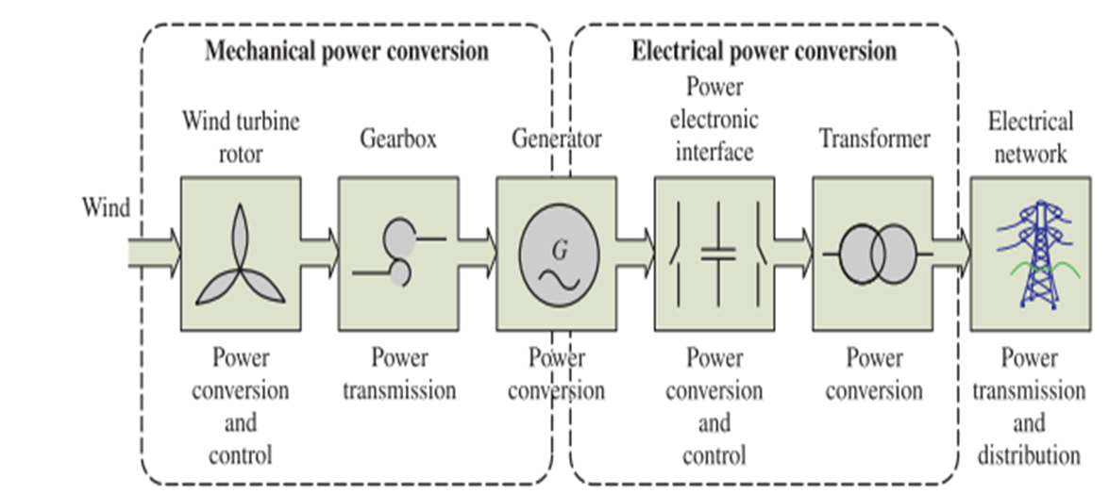

-magnet materials might change the philosophy of the adopted generator and drive trains of WTSs in order to avoid the risk of high expense. Between the grid and the generator, a power converter can be inserted where the transformers and filters have a pivotal role regarding the volume and losses of the entire system.

**BASIC CONTROL VARIABLES FOR WIND TURBINES**

[1] For a WTS, it is essential to be able to limit the mechanical power generated by the turbines under higher wind speeds in order to prevent overloading. The power limitation can be achieved by stall control (blade position is fixed but stall of the wind appears along the blade), active stall control (blade angle is adjusted in order to create stall along the blades), or pitch control (blades are turned out of the wind).

[1] The characteristics of the output mechanical power using the three types of power limitation methods are compared in given Figure. It can be seen clearly that pitch control can achieve the best power limitation performance, and it has already become the dominant technology in the most recently established wind turbines.

[1] Another control variable of wind turbines is the rotational speed of blades. In the past, this control freedom has not been utilized and the rotational speed is fixed during the entire operational range of Wind speeds. Although fixed speed turbines have the advantages of being simple and robust with low-cost electrical parts, the drawbacks are even more significant, such as uncontrollable electrical power, large mechanical stress during wind gusts, and limited output power quality.

[1] Nowadays, variable speed wind turbines are widely used in order to achieve better aerodynamic efficiency and overall control performance. By introducing variable speed operation, it is possible to continuously adapt the rotational speed of the wind turbine to the wind speed, such that the tip speed ratio is maintained constant in order to achieve the maximum power coefficient of the blades and, thereby, the maximum power-extracting efficiency of the wind turbine. The power variations in wind will be absorbed by the speed changes of the rotor; thus, the mechanical stress and acoustic noise can be reduced. In addition, the power converters used for speed adjustment can also provide better power controllability of the wind turbines, which helps fulfil the higher technical demands imposed by the grid operators. This feature is becoming a critical determining factor in the development of future wind power technologies.

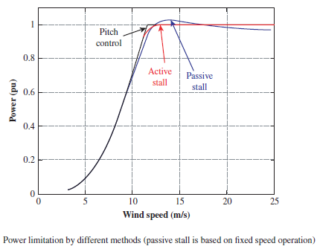

**VARIOUS TYPES OF WIND TURBINES**

**1. Fixed Speed Wind Turbines (WT Type A)** [1] ¬- The wind turbine is equipped with an asynchronous SCIG (Squirrel Cage Induction Generator) and smoother grid connection can be achieved by incorporating a soft starter, which is bypassed during the normal generation mode.

A disadvantage of this early concept is that a capacitor bank is required to compensate the reactive power demand from the asynchronous generator (AG). Because the rotational speed is fixed without any controllability, other considerations of mechanical parts must be strong enough to withstand adverse mechanical torque, and the wind speed fluctuations are transferred directly into the electrical power pulsations, which could yield to unstable voltage/efficiency in the case of a weak grid.

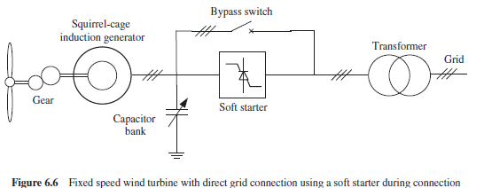

Fixed speed wind turbine with direct grid connection using a soft starter during connection

**2. Partial Variable Speed Wind Turbine with Variable Rotor Resistance (WT Type B)** [1] **-** This concept is also known as Opti Slip . It introduces the variable rotor resistance and, thus, limits the speed controllability of wind turbines. Typically, a Wound Rotor Induction Generator (WRIG) and the corresponding capacitor compensator are used, and the generator is connected directly to the grid by a soft starter, as with the Type A concept.

A technological improvement of this concept is that the rotational speed of the wind turbine can be partially adjusted by dynamically changing the rotor resistance. This feature contributes to mechanical stress relief and smoother output of electrical power. However, the constant power loss dissipating in the rotor resistors is a significant drawback for this concept.

**3. Variable Speed WT with Partial-Scale Frequency Converter (WT Type C) -**[1] Currently, this concept is the most established solution and it has been widely used since the start of the century. A back-to-back power electronic converter is adopted in conjunction with a DFIG (Doubly Fed Induction Generator). Use of a power electronic converter, flexibly regulates the frequency and current in the rotor and, thus, the variable speed range can be extended further to a satisfactory level. Meanwhile, the power converter can regulate partially the output power of the generator, improving the power quality and providing limited grid support. However, its main drawbacks are the use of slip rings and the challenging power controllability in the case of grid faults.

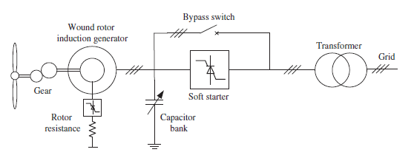

Partial-scale variable speed wind turbine with variable rotor resistance

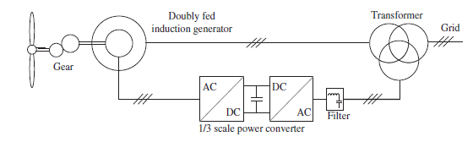

Variable speed wind turbine with partial-scale power converter and a doubly fed induction generator

**4. Variable Speed Wind Turbine with Full-Scale Power Converter (WT Type D) -**[1]It introduces a full-scale power converter to interconnect the power grid and stator windings of the generator; thus, all the power generated by the wind turbine can be regulated. In this concept, wound rotor synchronous generator (WRSG) and PMSG have all been reported. The elimination of slip rings, a simpler or even an eliminated gearbox, full power and speed controllability, as well as better grid support capability, are the main advantages of this solution compared with the DFIG-based concept. In the future, the voltage might be high enough to connect directly to the power grid without need of a bulky low-frequency transformer, this advantage might be an attractive feature for future WTSs.

**Table:** System comparison of wind turbine configurations [1]

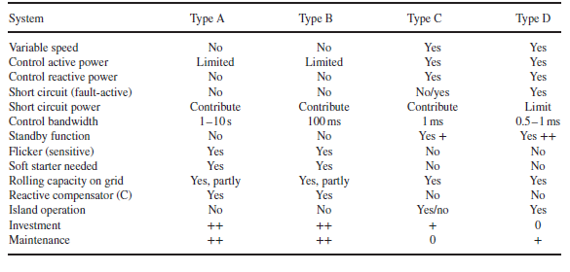

**SUPPLY CONFIGURATION OF DFIM**

[2] The doubly fed induction machine (DFIM) or wound rotor induction machine (WRIM) are terms commonly used to describe an electrical machine, which has been used over many decades in various applications, often in the range of megawatts of power and also less commonly in the range of a few kilowatts. This concept of the machine is as an alternative to more common asynchronous and synchronous machines. It can be advantageous in applications that have a limited speed range, allowing a reduction in the size of the supplying power electronic converter as, for instance, in variable-speed

Generation, water pumping and so on.

[2] The typical supply configuration of the DFIM is shown in Figure. The stator is supplied by three-phase voltages directly from the grid at constant amplitude and frequency, creating the stator magnetic field. The rotor is also supplied by three-phase voltages that take a different amplitude and frequency at steady state in order to reach different operating conditions of the machine (speed, torque, etc.). This is achieved by using a back-to-back three-phase converter, as represented in the simple schematic in the figure. This converter, together with the appropriate control strategy, is in charge of imposing the required rotor AC voltages to control the overall DFIM operating point and to perform the power exchange through the rotor to the grid. Although a voltage source converter is shown, different configurations or converter topologies could be utilized.

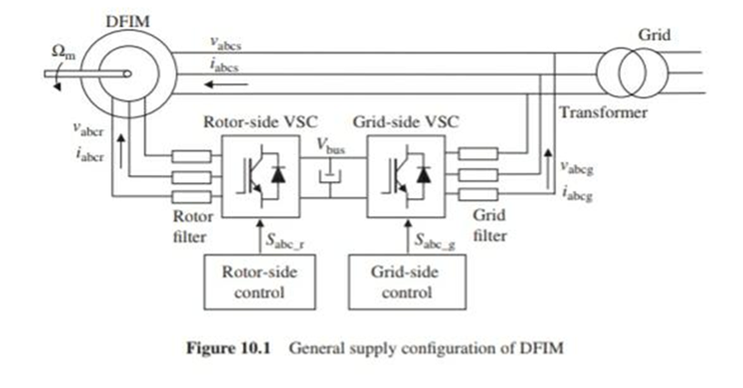

General Supply configuration of DFIM

**DFIM-BASED WIND ENERGY CONVERSION SYSTEMS**

**Wind Turbine Aerodynamic**

[1] This section analyses the most important issues of DFIM-based pitch-regulated variable-speed wind turbines. In this type of modern wind turbine, the energy from the wind is captured mechanically by the blades, then it is converted to electric energy by the DFIM, and finally, this energy is delivered to the electricity network . The theory of momentum issued to study the behaviour of the wind turbine. Under certain ideal assumptions, the wind turbine can recover the power from wind given by the expression:

**Pt = 1/2×π×(R)^2×ρ×(Vw)^3×Cp**

Where ρ is the air density, R is the radius of the blades of the wind turbine, Vw is the wind speed and Cp is The power coefficient; a dimensionless parameter that expresses the effectiveness of the wind turbine in the transformation of the kinetic energy of the wind into mechanical energy.

For a given wind turbine, this coefficient is a function of wind speed, the speed of rotation of the wind turbine Ωt and the pitch angle β, Cp is often given as a function of the tip speed ratio λ, which is defined by

**λ= RΩt/Vw**

**Cp = f(β,λ)**

with

The theoretical maximum value of Cp is given by the Betz limit: Cp_theo_max = 0.593.

**Figure(a),(b): shows graphically an example of Cp curves.**

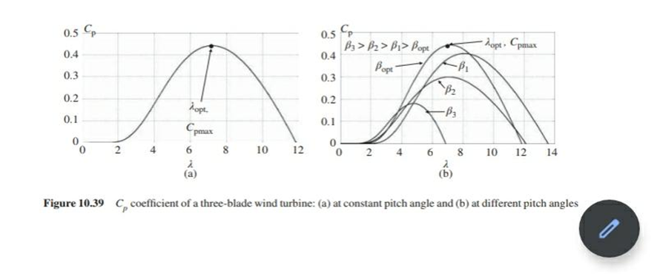

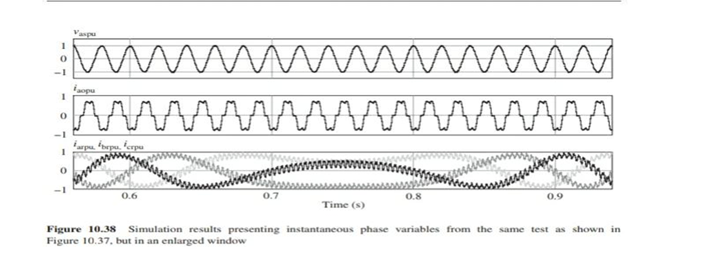



**TURBINE CONTROL ZONES**

[1] Under the assumption of an ideal mechanical coupling and neglecting possible losses of the gearbox, located between the turbine rotor and the DFIMs, the power generated by the wind turbine Pt is transmitted completely to the shaft of the DFIM; thus, Pm = Pt. Therefore, by evaluating expressions for different wind speeds and different rotational speeds of the wind turbine (the pitch is maintained constant to its optimal position 𝛽opt), the captured power from the wind can be represented in three-dimensional space, as illustrated in Figure (a). This is a representative example of a multi-megawatt wind turbine for which a specific radius R has been selected. It can be seen that at each constant wind speed, the curve presents a maximum point of generated power at one specific rotational speed. This property of wind turbines is exploited by means of the variable speed control, which always tries to choose the appropriate rotational speed at any given wind speed, in order to capture the maximum available power from the wind. However, in Figure (a), the points at which the wind turbine operates are also shown. It can be noted that it is not always possible to operate at the points of maximum power of the curves. This is because of the restriction of the maximum Ωt_nom and minimum Ωt_min rotational speeds of the wind turbine. Depending on the turbine’s design, the speed is limited by efficiency and safety concerns. For most turbine designs, these speed limitations yield four zones of operation relating to the rotational speed. Projections of Figure (a) into the three planes illustrated in Figure (b–d) help to delineate these four operating zones (note that the gearbox relation holds: NΩt = Ωm).

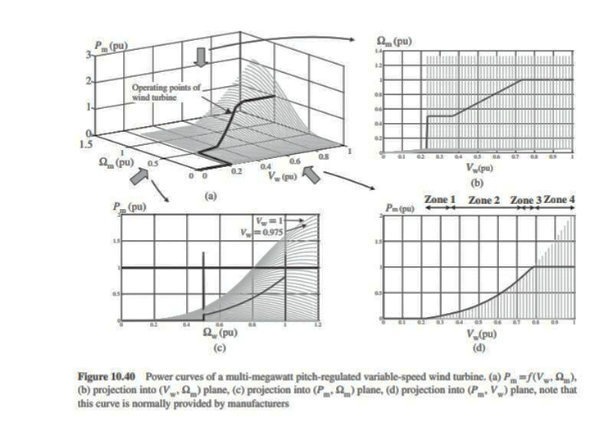

**Figure(above):**

Power curves of a multi-megawatt pitch-regulated variable-speed wind turbine. (a) *P*m =*f* (*V*w, Ωm), (b) projection into (*V*w, Ωm) plane, (c) projection into (*P*m, Ωm) plane, (d) projection into (*P*m, *V*w) plane, note that this curve is normally provided by manufacturers.

**ZONE 1:** In this zone, the rotational speed is limited and maintained constant to its minimum value; therefore, it is not possible to extract the maximum power from the wind. In this example of a wind turbine, between wind speeds of 0.235 and 0.36 pu, the captured power is not maximum.

**ZONE 2:** In this zone, the rotational speed can be varied achieving the maximum point of the power curves. Within this zone, generally, a maximum power point tracking (MPPT) strategy is carried out. Therefore, between wind speeds of 0.36 and 0.73 Pu, the rotational speed is modified, always seeking the maximum of the power curves.

**ZONE 3:** This zone appears in some turbine designs when the maximum rotational speed is reached but not that of the maximum generated power. For this turbine design, between wind speeds of 0.73 and 0.78 Pu, the rotational speed must be maintained at the maximum value, although it is not possible to capture the maximum power from the wind and, therefore, it is not operating at the maximum of the power curves.

**ZONE 4:** This zone begins when the captured power is equal to that of the rated power, which for this turbine example is at 0.78 Pu wind speed. In this zone, the generated power and speed are maintained constant at their maximum values by modifying the pitch angle. Thus, the blades are gradually pitched out of the wind, because it is possible to maintain constant captured power, even if the wind speed increases.

It must be highlighted that it is possible to find in the literature slightly alternative representations of the turbine control zones presented in this section.

**TURBINE CONTROL**

[1] Having seen that the wind turbine can operate at four different zones according to the rotational speed, this section presents the general control strategy of the wind turbine (Figure a). The DFIM is vector controlled by the rotor-side converter, as described, for instance, but by omitting the speed control loop and translating to the wind turbine control block (if necessary), as is discussed later . Thus, this new wind turbine control block generates the torque and pitch references in order to determine the four zones of operation. The grid-side converter is also vector controlled and is responsible for evacuating the generated power to the grid through the rotor of the machine and for controlling the DC bus voltage of the back-to-back converter. Qs And Qg references are generated by the reactive power generation strategy, assisting to the grid with the necessary reactive power, as demanded by the grid operator.

Figure: b shows some possible wind turbine control block philosophies for each operating zone.

As can be noted, zones 1 and 3 present the same control structure. The speed is regulated as constant with regard to the maximum or minimum value by means of the electromagnetic torque generated by the DFIM. Generally, in this situation, the pitch angle is maintained constant. On the other hand, in zone 4, the speed is also regulated as constant with regard to the maximum value, but in this case, by actuating the pitch angle and keeping the electromagnetic torque constant. Finally, the MPPT of zone 2 can be performed according to different control philosophies. For instance, it is possible to use an indirect speed control (ISC) by exploiting the fact that when the MPPT is achieved (operation at Cp_max), the generated power follows a cubic relation to the speed as follows:



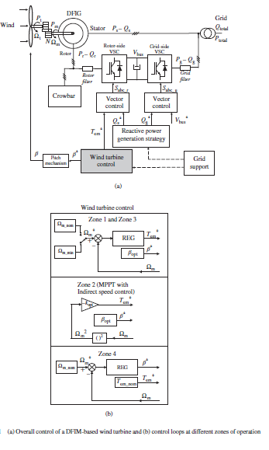

**POWER CONVERTERS FOR WIND TURBINES**

[1] Because of the rapid development of capacity and technology in wind power generation, the power electronic converter is becoming an increasingly important part of the entire system. However, power electronic converters also need to satisfy requirements that are much tougher than ever before. Generally, these requirements can be categorized into the following three groups, as shown in Figure below:

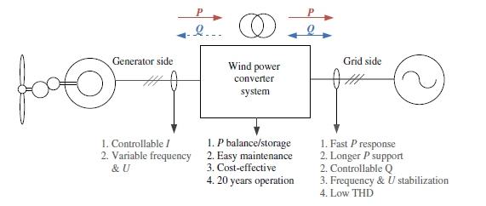

Requirements of modern wind power converters

**Two-Level Power Converter**

[1] A pulse width modulation-voltage source converter with two-level output voltage (2L-PWM-VSC) is the most frequently used three-phase topology in wind power applications. The knowledge available in this converter topology is extensive and well established. However, the 2L-PWM-VSC topology might

suffer from larger switching losses and lower efficiency at MW and medium-voltage (MV) levels. The available switching devices or converter building blocks might need to be connected in parallel or in series in order to obtain the required power and voltage. Another problem of the 2L-PWM-VSC is the two-level output voltage, which introduces relatively higher d*v*/d*t* stresses to the generator and transformer windings and bulky output filters might be necessary to limit the voltage gradient and reduce the harmonics level. In WTSs, the 2L-PWM-VSC can be used in different configurations:

**Two-Level Unidirectional Voltage Source Power Converter (2L-UNI)**

[1] It is becoming a trend to use PMSG for wind turbine concepts with full-scale power converters. Because there is no reactive power required in such a generator and because active power flows unidirectional from the generator to the power grid, only a simple diode rectifier need be applied on the generator side, which achieves a cost-efficient solution, as shown in Figure. However, the diode rectifier might introduce low-frequency torque pulsations that could trigger shaft resonance. Semi controlled rectifier solutions are also possible using this circuit topology.

In order to obtain variable speed operation and a stable DC bus voltage, a boost DC/DC converter could be inserted in the DC-link, or the DC-voltage could be controlled by using rotor excitation, as shown in Figure. It must be mentioned that for power levels in the range of MW, the DC/DC converter needs to be made by several interleaved units or by a three-level solution.

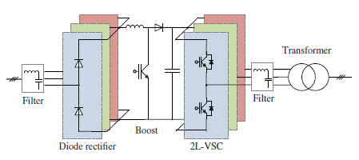

Two-level unidirectional voltage source converter for wind turbine (2L-UNI) [7]

**Two-Level Back-To-Back Voltage Source Power Converter (2L-BTB)**

[1] It is very popular to configure two 2L-PWM-VSCs in a back-to-back structure (2L-BTB) in the wind power conversion system, as shown in Figure . A technical advantage of the 2L-BTB solution is the full power controllability (four-quadrant operation) with a relatively simple structure and few components, which contributes to a well-proven robust and reliable performance. The 2L-BTB topology is a state-of-the-art solution in DFIG-based wind turbines .Several manufacturers are also using this topology for a full-scale power converter concept with an SCIG.

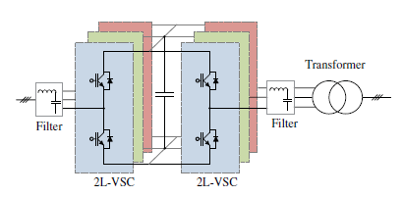

Two-level back-to-back voltage source converter for wind turbine (2L-BTB)

**Multilevel Power Converter**

[1] With the capabilities of more output voltage levels, higher voltage amplitude and larger power handling ability, the multilevel converter topologies are becoming interesting and promising candidates in the wind turbine applications. Generally, the multilevel converters can be classified into three categories: neutral-point diode clamped, flying capacitor clamped and cascaded converter cells. In order to achieve a cost-effective design, multilevel converters are mainly used in 3 – 8 MW variable speed wind turbines with full-scale power converters.

### Three-Level Neutral-Point Diode Clamped Back-To-Back Topology (3L-NPC BTB)

[1] The three-level neutral-point diode clamped topology is one of the most commercialized multilevel topologies on the market. Similar to the 2L-BTB, it is usually configured as a back-to-back structure in wind turbines, as shown in Figure, which for convenience, is called 3L-NPC BTB.

It achieves one more output voltage level and less dv/dt stress compared with the 2L-BTB; thus, the filter size is smaller.

The 3L-NPC BTB is also able to double the voltage amplitude compared with the 2L-BTB converter via switching devices with the same voltage rating. The mid-point voltage fluctuation of the DC bus used to be a drawback of the 3L-NPC BTB, but this problem has been researched extensively and is considered improved by the controlling of redundant switching states [30]. However, it is found that the loss distribution is unequal between the outer and inner switching devices in a switching arm, and this problem might lead to de-rated power capacity when it is practically designed.



Transformer

Filter

Filter

Three-level neutral-point clamped back-to-back converter for wind turbine (3L-NPC BTB)

**Three-Level H-Bridge Back-To-Back Topology (3L-HB BTB)** [1] The 3L-HB BTB solution comprises two 3-phase H-bridge converters configured in a back-to-back structure, as shown in Figure. It achieves an output performance similar to the 3L-NPC BTB solution, but the unequal loss distribution and clamped diodes can be avoided. Thereby, more efficient and equal loading of the power switching devices, as well as higher designed power capacity, might be obtained.

Moreover, as only half of the DC bus voltage is needed in the 3L-HB BTB compared with the 3L-NPC BTB, there are fewer series connections of capacitors and no mid-point in the DC bus; thus, the size of the DC-link capacitors can be reduced further.

However, the 3L-HB BTB solution needs an open-winding structure both in the generator and in the transformer in order to achieve isolation among each phase. This feature has advantages and disadvantages.

On the one hand, a potential fault-tolerant ability is obtained, if one or even two phases of the generator are out of operation. On the other hand, doubled cable length is needed and extra cost, weight, loss and inductance can be major drawbacks in such a converter configuration.



Transformer open windings

Filter

Filter

Three-level H-bridge back-to-back converter for wind turbine (3L-HB BTB)

**Five-Level H-Bridge Back-To-Back Topology (5L-HB BTB)**

[1] The 5L-HB BTB converter comprises two 3-phase H-bridge converters making use of 3L-NPC switching arms, as shown in Figure. This is an extension of the 3L-HB BTB solution and shares the same requirements for an open-winding generator and transformer. The 5L-HB BTB can achieve five-level output voltage and double the voltage amplitude compared with the 3L-HB BTB solution with the same devices. These features enable the use of smaller output filters and lower current rating in the switching devices and cables. However, the 5L-HB BTB converter introduces more switching devices,

Which could reduce the reliability of the total system.

Five-level H-bridge back-to-back converter for wind turbine (5L-HB BTB)

**POWER SEMICONDUCTORS FOR WIND POWER CONVERTER**

[1] As the backbone component for the converters, power semiconductor devices are also playing an important role in the development of high-performance wind turbines. The dominant choices for power switching devices, as reported in the wind power industry, are based on the module packaging insulated gate bipolar transistor (IGBT), the presspack packaging IGBT and the presspack packaging integrated gate-commutated thyristor (IGCT).

The module packaging technology for IGBT has a longer record of applications and fewer hardware-mounting regulations. However, owing to the soldering and bond wire connections of the internal chips, module packaging devices might suffer from larger thermal resistance, lower power density and higher failure rates. The presspack packaging technology improves the connection of the chips by direct presspack contacting, which leads to improved reliability (known from industrial experience), higher power density (easier stacking for connection) and better cooling capability, but with the disadvantage of higher cost compared with the module packaging devices. Presspack IGCTs were introduced into MV converters in the 1990s and are already becoming state-of-the-art technology used in high-power motor drives, but they have not yet been adopted widely in the wind power industry.

**CONTROLS AND GRID REQUIREMENTS FOR MODERN WIND TURBINES**

[1] Controlling a wind turbine involves both fast and slow control dynamics. Generally, the energy flowing in and out of the generation system has to be managed carefully. The power generated by turbines should be controlled by means of mechanical parts (e.g., pitch angle of blades and yawing system). Meanwhile, the entire control system has to follow the power production commands given by the transmission system operator (TSO). The more advanced features of wind turbine might be taken into account in the control system, such as the maximization of the generated power, riding through the grid faults and providing grid support.

[1] With the concept of variable speed wind turbines, the current in the generator will typically be changed by controlling the generator-side converter and thereby, the rotational speed of the turbine rotor can be adjusted to achieve maximum power production based on the available wind power. Regarding the grid fault and support conditions, coordinated control by several subsystems of the wind turbine, such as the grid-side converter, braking chopper, pitch angle system and generator, might be necessary. Finally, basic control, such as current regulation, DC bus stabilization and grid synchronization has to be performed quickly by the power converter; proportional-integral (PI) controllers and proportional-resonant (PR) controllers are typically used. Most countries have dedicated grid codes for wind turbines and they are updated regularly. In most cases, these requirements reflect the significant penetration of wind power into the grid system, and the requirements cover a wide range of voltage levels from MV to very high voltage. Basically, the grid codes are always trying to make wind farms act as conventional power plants from the point of view of the electricity network. Thus, generally, the focus is on the power controllability, power quality, fault ride-through capability and grid support capability of WTSs during network disturbances.

Examples of grid codes in different countries for active and reactive power control, power quality and ride-through capabilities are given in the following, and they are regulations either for individual wind turbines or for the entire wind farm.

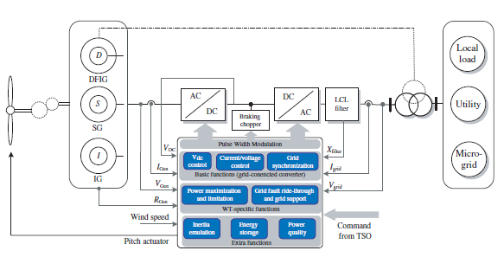

General control structure for modern wind turbines

**Active Power Control**

[1] According to most grid codes, individual wind turbines must be able to control the active power in the point-of-common coupling (PCC) within a given power range. Typically, the active power is controlled based on the system frequency for larger generation units on the wind farm scale, which are normally connected at the transmission line, the wind turbines should act as conventional power plants providing a wide range of controlled active power based on the demands of the TSO.

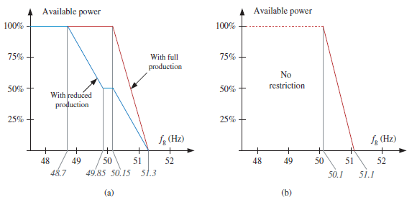

Frequency control profiles for wind turbines connected to (a) the Danish grid and (b) the German grid

**Reactive Power Control**

[1] During normal operation, the reactive power delivered by the wind turbine or wind farm also has to be regulated by the grid codes within a certain range. The grid codes in different countries specify different reactive power control behaviors. Danish and the German grid codes give a range for controlling the reactive power of the WTS against the active power output. In addition, the TSOs will normally specify the reactive power range delivered by wind farms according to the grid voltage levels.

**Total Harmonic Distortion**

[1] Power quality issues are addressed especially for wind turbines connected to MV networks. However, some grid codes, for example, in Denmark and Ireland, also have requirements at a transmission level. Generally, two standards are used for defining the power quality parameters, namely, IEC 61000-x-x and EN 50160. Specific values are given for fast variations in voltage, short-term flicker severity, long-term flicker severity and THD. The limits for individual orders of harmonic distortion are also given based on standards, or in some cases, for example, Denmark, on custom-defined harmonic compatibility levels. Inter-harmonics might also be considered by the grid codes.

**MATLAB SIMULATION I – IMPLEMENTATION AND CONTROL OF DOUBLY FED INDUCTION MACHINE**

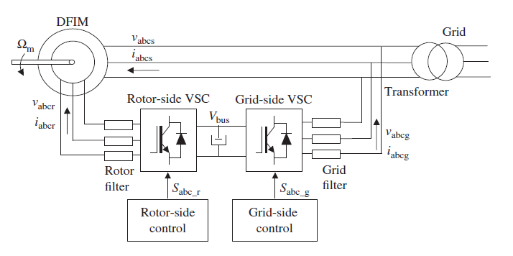

The required block diagram which is implemented in the Simulink is as below:

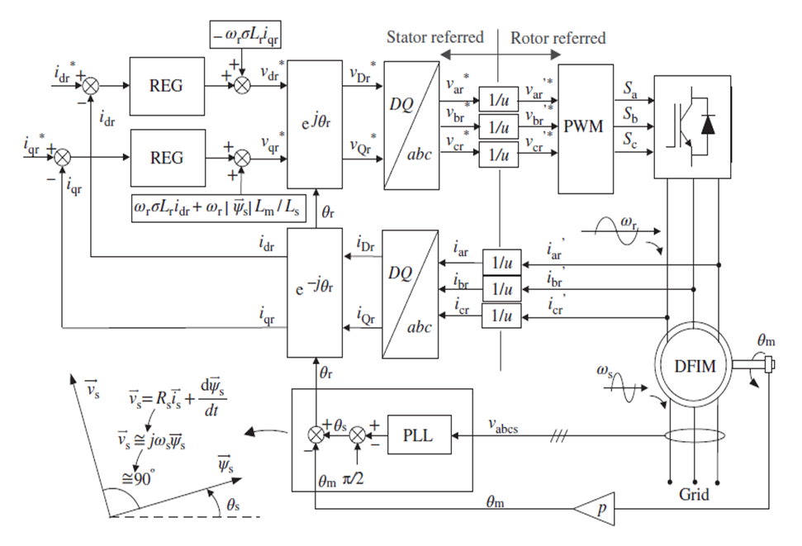

The Simulink model after implementation in the model is as follows:

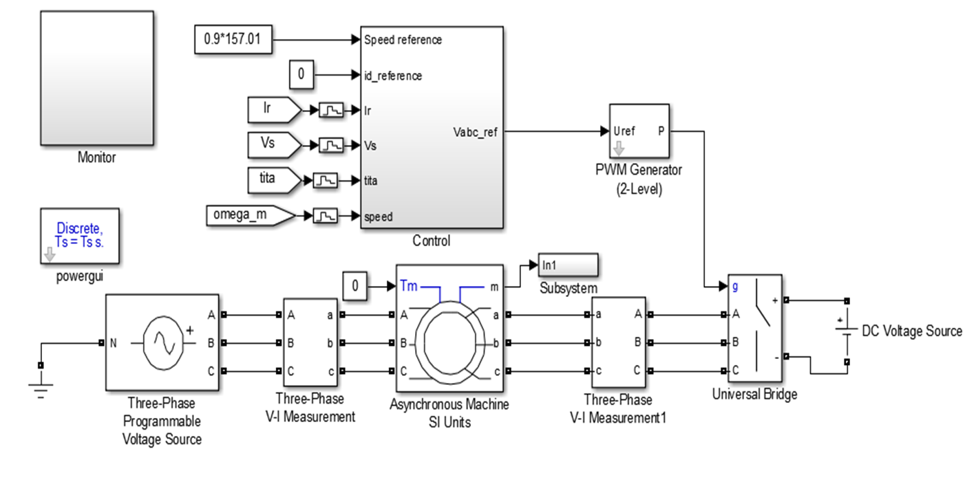

The entire control circuit is shown below as:

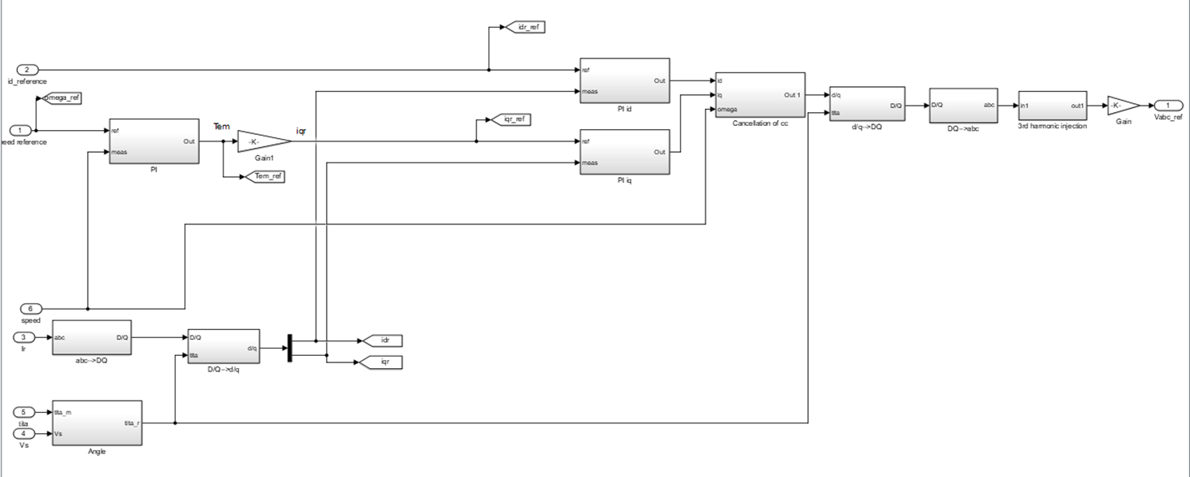

The MATLAB script which is run in editor is given which contains various machine parameters and PID parameters is:

close all

clear all

clc

%% DFIG Parameters -> Rotor parameters referred to the stator side

f = 50; % Stator frequency (Hz)

Ps = 2e6; % Rated stator power (W)

n = 1500; % Rated rotational speed (rev/min)

Vs = 690; % Rated stator voltage (V)

Is = 1760; % Rated stator current (A)

Tem = 12732; %Rated torque (N.m)

p=2; % Pole pair

u = 1/3; % Stator/rotor turns ratio

Vr = 2070; % Rated rotor voltage (non-reached) (V)

smax = 1/3; % Maximum slip

Vr_stator = (Vr*smax)*u; % Rated rotor voltage referred to stator V)

Rs = 2.6e-3; % Stator resistance (ohm)

Lsi = 0.087e-3; % Leakage inductance (stator and rotor) (H)

Lm = 2.5e-3; % Magnetizing / Mutual inductance (H)

Rr = 2.9e-3; % Rotor resistance referred to stator (ohm)

Ls = Lm + Lsi; % Stator inductance (H)

Lr = Lm + Lsi; % Rotor inductance (H)

Vbus = Vr_stator*sqrt(2); % DC de bus voltage referred to stator (V)

sigma = 1 - Lm^2/(Ls*Lr); %

Fs = Vs*sqrt(2/3)/(2*pi*f); % Stator Flux (approx.) (Wb)

%Mechanical Parameters

J = 127; % Inertia force

D = 1e-3; % Friction Pair

fsw = 4e3;

Ts = 1/fsw/50;

%PI regulators

tau_1 = (sigma*Lr)/Rr;

tau_n = 0.05;

wn1 = 100*(1/tau_1);

wnn = 1/tau_n;

kp_id = (2*wn1*sigma*Lr)-Rr;

kp_iq = kp_id;

ki_id = (wn1^2)*Lr*sigma;

ki_iq = ki_id;

kp_n = (2*wnn*J)/p;

ki_n =((wnn^2)*J)/p;

%Initial Slip Conditions [1 0 0 0 0 0 0 0]. Machine will start from 0 speed

At No load and 90% of synchronous speed

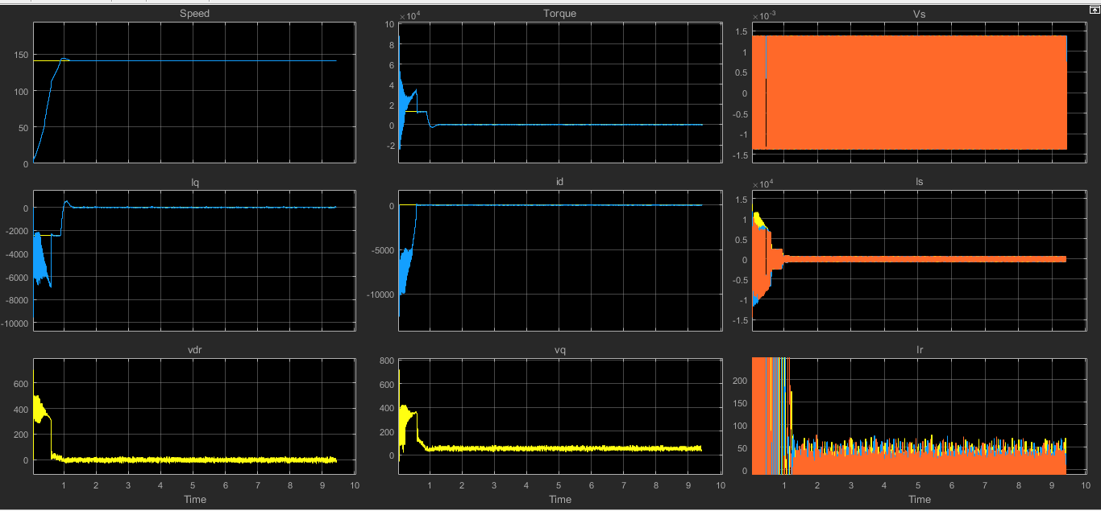

At No load and 90% of synchronous speed (zoomed for clarity)

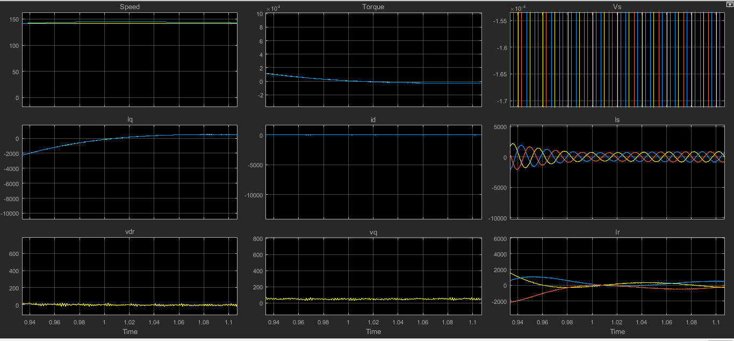

At 25% of Rated load And 90% of Synchronous Speed

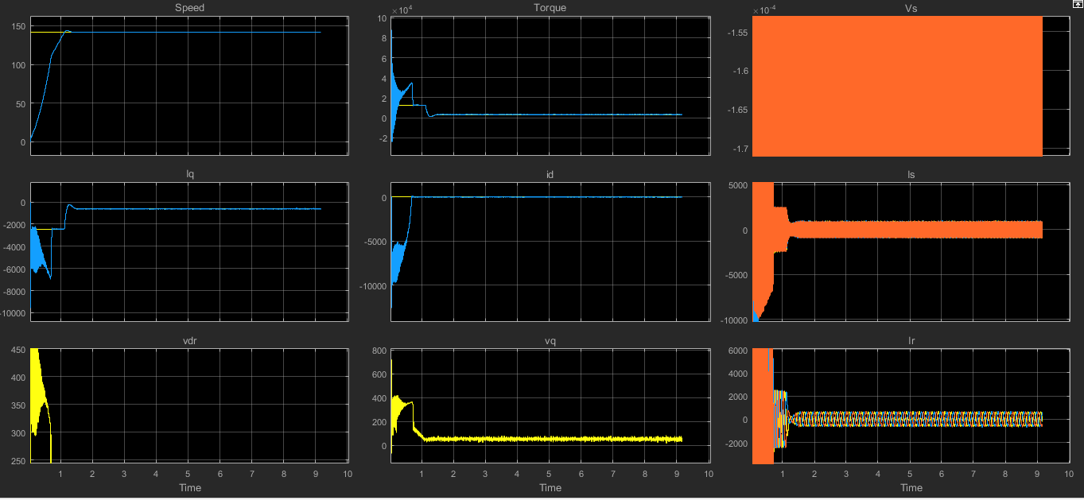

At 25% of Rated load and 90% of Synchronous Speed (zoomed for clarity)

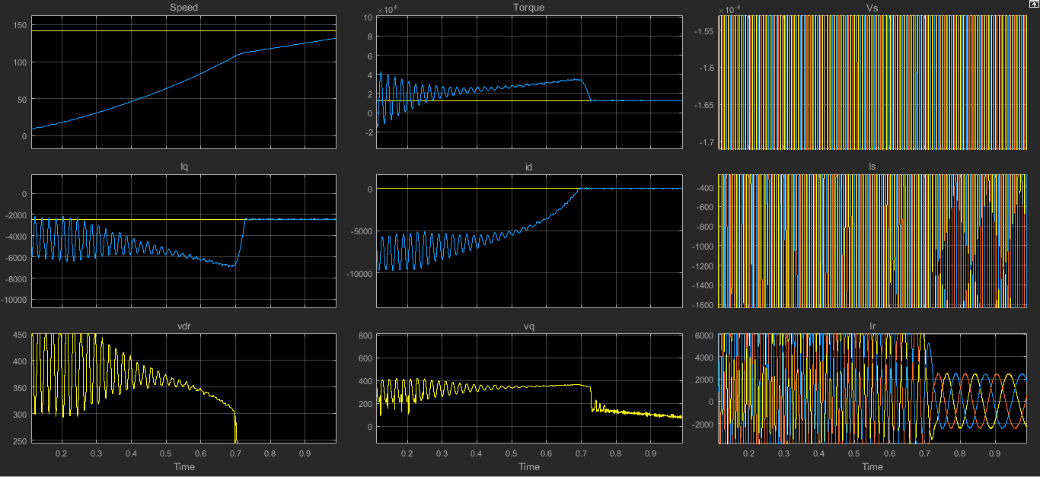

At 25% of Rated load and 100% of synchronous speed the machine acts as dfi motor

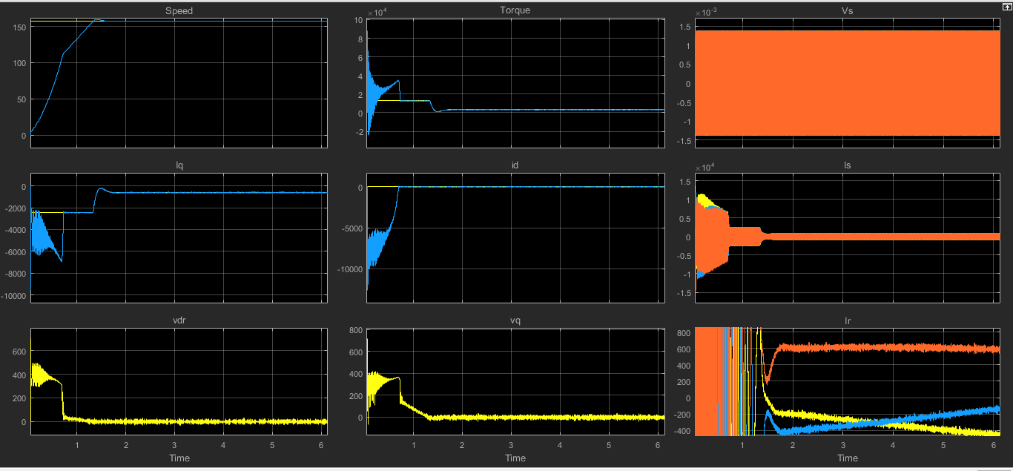

At 25% of Rated load And 100% of synchronous speed the machine acts as dfi motor (zoomed for clarity)

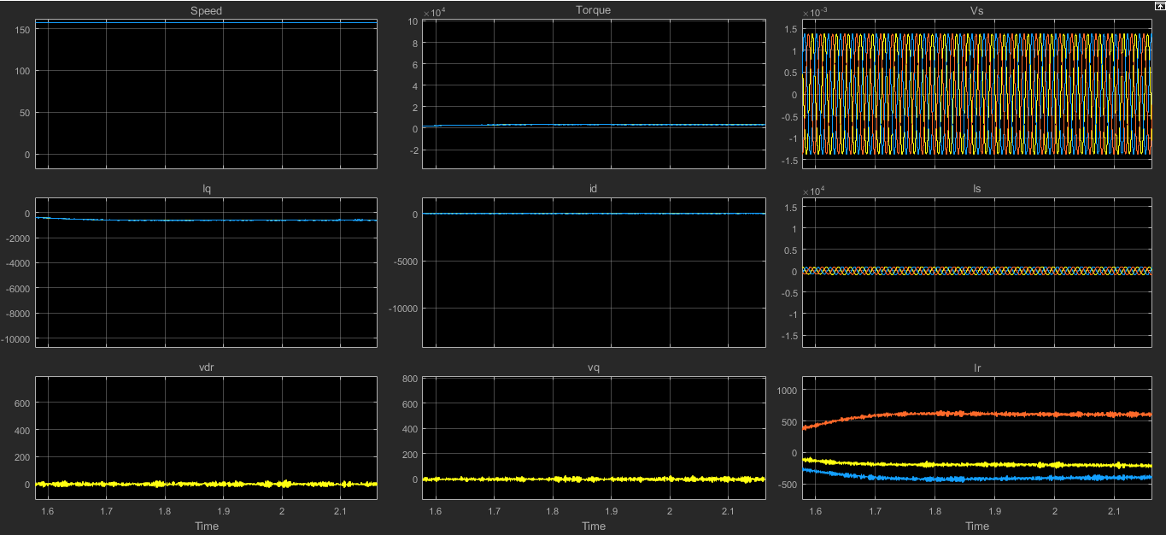

At -25% of Rated load and 1.1 of synchronous speed and the machine acts as dfi generator

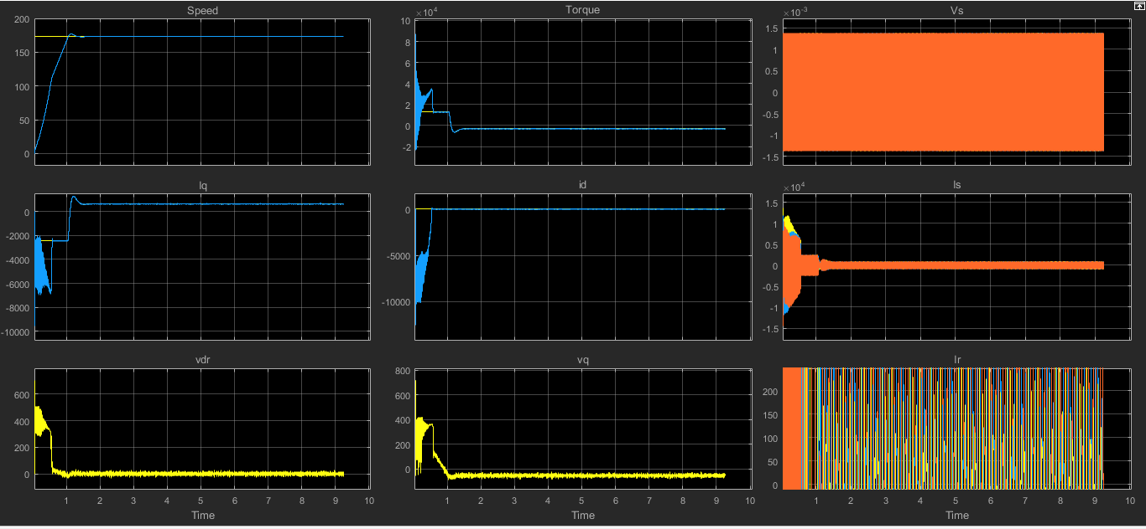

At -25% of Rated load and 1.1 of synchronous speed and the machine acts as dfi generator (zoomed for clarity)

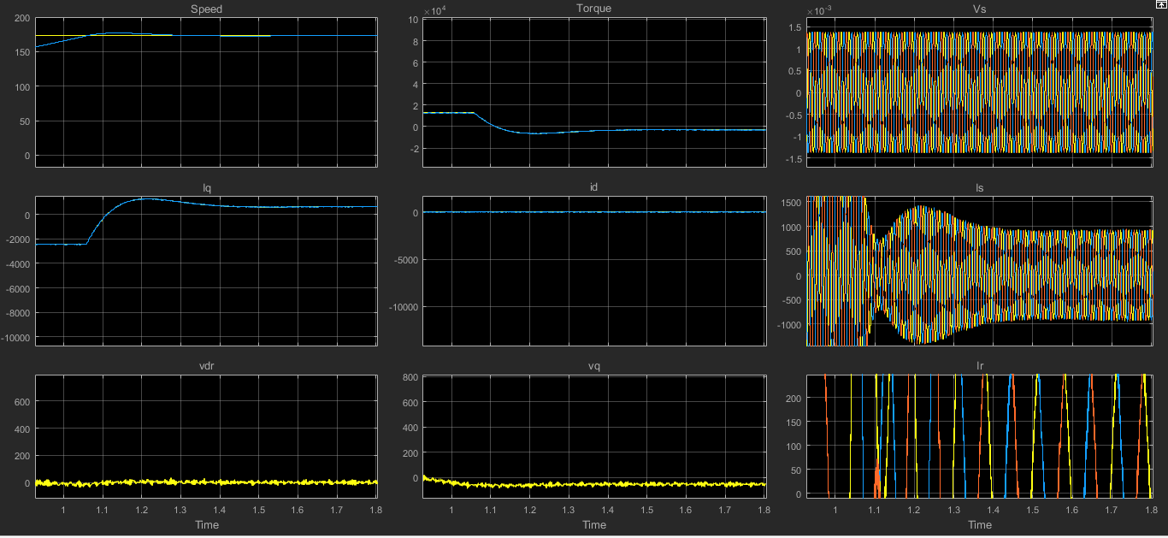

Here we have performed the implementation and control of doubly fed induction machine (DFIM) using MATLAB Simulink. It is useful for understanding, for instance wind turbines for doubly fed induction generators.

First we will implement the rotor side control for the DFIM.

By the three phase VI measurements instruments we are measuring Vs, Is and Ir , Vr . The power electronic converter is the universal ideal switch. We need to control the voltage source converter by means of a PWM modulation. Since we are using only rotor side control and grid side control is not required here so we are using a DC voltage source across the power electronic converter. The various parameters of asynchronous machine and other parameters of the controller or initialised in the initialisation program. The DC voltage source used is initialised to Vbus voltage and the PWM generator used is six pulse type and its frequency is in initialised to the sampling frequency fsw . This is the overall power circuit.

Now we will design the control circuit which controls the entire system. The control strategy that we have used in the DFIM is shown above. One loop have to be added at the current site in order to control the speed of the shaft of the machine. The speed reference, Id_reference, Vs, Ir , angle of the shaft and speed of the shaft are taken as the input reference for the control circuit . The normalization (1/u) is not needed here since the DFIM model in MATLAB is automatically implemented referred to the rotor side. The DQ transformation are required here. Since the PWM generator uses normalised triangular waveform so the output of DQ to abc should also be normalised one. The third harmonic injection is used to increase the DC bus voltage by about 15%. From the PLL we will get the angle of the shaft from which we have to subtract 90 degree to get the stator angle; from which the electrical angle is subtracted to get the rotor angle.

The PI controller is used to regulate the id current in order to reduce the overshoot and reduce the steady state error of the overall system. Similar PI controller is used to regulate the iq current. Now the coupling terms are cancelled which are quite complex for which the cancellation block is used. The speed regulators are implemented. The scope is implemented inside the monitor to analyse the performance curves or waveforms. The zero order hold circuits are used to make the system work close to the reality.

We will now operate the machine at different operating points:

* At speed_ref = 90% of synchronous speed = 0.9 * 157.14 and zero load torque.

The speed of the motor is going up or is increasing slowly and slowly. A strong perturbation is caused because we are starting the machine directly connected to the grid which is not done in practical situation. Here we are not doing a correct start up for the sake of simplicity but once the start-up is reached the system is being controlled properly.

* At load = 0.25 * Tem = 25% of rated load and 90% of synchronous speed. The torque has shown some rapid movement since it is now loaded and there are some perturbation in speed. There is also the difference in the frequency of the Is and Ir.
* At synchronous speed and load = 0.25 * Tem . There is the step reference change in speed and we are reaching the reference speed, little by little and initially some overshoot were there. The torque is also working properly.

The synchronous speed at steady state we can also see the Ir are almost DC not sinusoidal anymore. At this operating point DFI machine is working as a synchronous Motor with DC currents present at the rotor.

* At 1.1* synchronous speed at 0.25 * Tem .The step change again occurs in the speed and rated torque is there during the transients and there will be some overshoot in present in the speed curve what will go down as the steady state is reached .
* At 1.1* synchronous speed and –Tem * 0.25. The load torque is negative for generator operation. Then there’s a strong perturbation at the torque, iq current is also working properly but after few milliseconds the steady state will be reached as well.

The torque is modified according to the speed and iq current is modified according to the torque. The id current has been more or less maintained at zero and so voltage Vdr is also more or less at zero. Here there are DC currents as in the abc sequence so we were at the synchronous operation at that time.

**MATLAB SIMULATION II – IMPLEMENTATION OF SIMPLE WIND TURBINE MODEL USING DFIG**

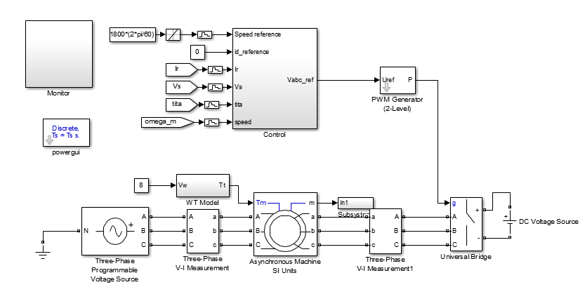

THE CONTROL STRATEGY AS IMPLEMENTED:

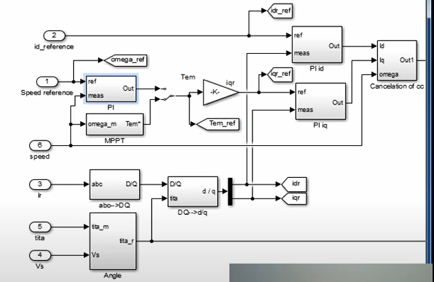

THE WT MODEL AS IMPLEMENTED:

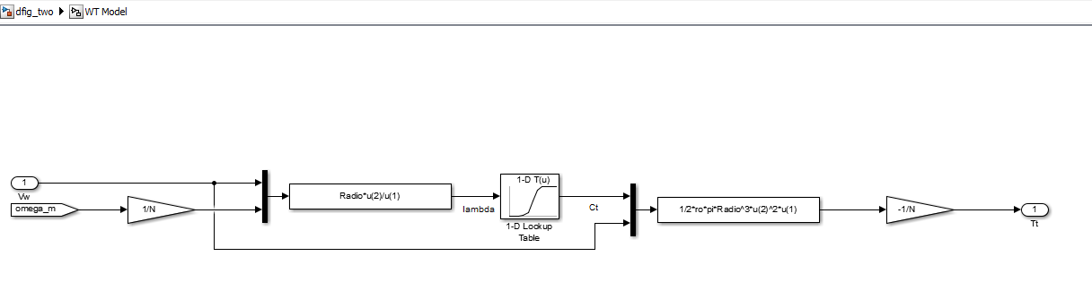

THE MPPT STRATEGY AS IMPLEMENTED:

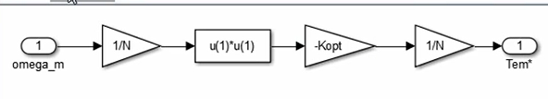

MPPT STRATEGY (INDIRECT SPEED CONTROL):

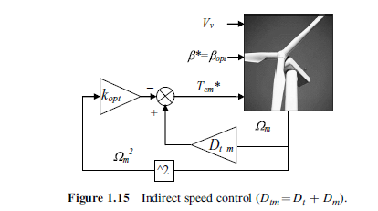

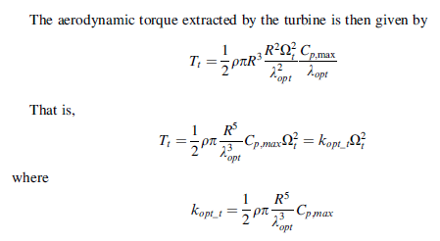

POWER VS WIND SPEED CURVE AND Ct VS LAMBDA CURVE:

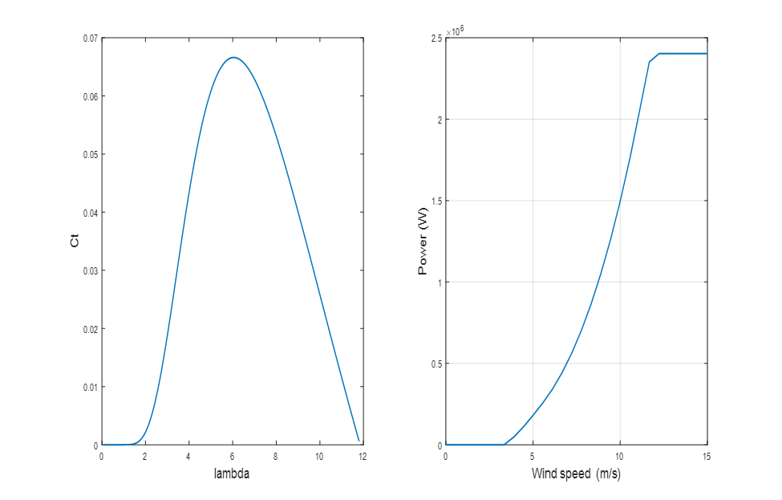

The MATLAB script which is run in editor is given which contains various machine parameters and PID parameters is:

close all

clear all

clc

%% DFIG Parameters -> Rotor parameters referred to the stator side

f = 50; % Stator frequency (Hz)

Ps = 2e6; % Rated stator power (W)

n = 1500; % Rated rotational speed (rev/min)

Vs = 690; % Rated stator voltage (V)

Is = 1760; % Rated stator current (A)

Tem = 12732; %Rated torque (N.m)

p=2; % Pole pair

u = 1/3; % Stator/rotor turns ratio

Vr = 2070; % Rated rotor voltage (non-reached) (V)

smax = 1/3; % Maximum slip

Vr_stator = (Vr*smax)*u; % Rated rotor voltage referred to stator (V)

Rs = 2.6e-3; % Stator resistance (ohm)

Lsi = 0.087e-3; % Leakage inductance (stator and rotor) (H)

Lm = 2.5e-3; % Magnetizing / Mutual inductance (H)

Rr = 2.9e-3; % Rotor resistance referred to stator (ohm)

Ls = Lm + Lsi; % Stator inductance (H)

Lr = Lm + Lsi; % Rotor inductance (H)

Vbus = Vr_stator*sqrt(2); % DC de bus voltage referred to stator (V)

sigma = 1 - Lm^2/(Ls*Lr); %

Fs = Vs*sqrt(2/3)/(2*pi*f); % Stator Flux (approx.) (Wb)

%Mechanical Parameters

J = 127/2; % Inertia

D = 1e-3; % Damping

fsw = 4e3; % Switching frequency (Hz)

Ts = 1/fsw/50; % Sample time (sec)

%PI regulators

tau_1 = (sigma*Lr)/Rr;

tau_n = 0.05;

wn1 = 100*(1/tau_1);

wnn = 1/tau_n;

kp_id = (2*wn1*sigma*Lr)-Rr;

kp_iq = kp_id;

ki_id = (wn1^2)*Lr*sigma;

ki_iq = ki_id;

kp_n = (2*wnn*J)/p;

ki_n =((wnn^2)*J)/p;

%Three blade wind turbine model

N=100; % Gearbox ratio

Radio= 42; % Radio

ro =1.225; % Air density

% Cp and Ct curve

beta=0; % Pitch angle

ind2=1;

for lambda=0.1:0.01:11.8

lambdai(ind2)= (1./((1./(lambda-0.02.*beta)+(0.003./(beta^3+1)))));

Cp(ind2)=0.73.*(151./lambdai(ind2)-0.58.*beta-0.002.*beta^2.14-13.2).*(exp(-18.4./lambdai(ind2)));

Ct(ind2)=Cp(ind2)/lambda;

ind2=ind2+1;

end

tab_lambda=[0.1:0.01:11.8];

% Kopt for MPPT

Cp_max = 0.44;

lambda_opt = 7.2;

Kopt = ((0.5*ro*pi*(Radio^5)*Cp_max)/(lambda_opt^3));

% Power curve in function of wind speed

P = 1.0e+06 *[0,0,0,0,0,0,0,0.0472,0.1097,0.1815,0.2568,0.3418, ...

0.4437,0.5642,0.7046,0.8667,1.0518,1.2616,1.4976,1.7613,2.0534,...

2.3513,2.4024,2.4024,2.4024,2.4024,2.4024,2.4024];

V = [0.0000,0.5556,1.1111,1.6667,2.2222,2.7778,3.3333,3.8889,4.4444,...

5.0000,5.5556,6.1111,6.6667,7.2222,7.7778,8.3333,8.8889,9.4444, ...

10.0000,10.5556,11.1111,11.6667,12.2222,12.7778,13.3333,13.8889,...

14.4444,15.0000]

figure

subplot(1,2,1)

plot(tab_lambda,Ct,'linewidth',1.5)

xlabel('lambda','fontsize',14)

ylabel('Ct','fontsize',14)

subplot(1,2,2)

plot(V,P,'linewidth',1.5)

grid

xlabel('Wind speed (m/s)','fontsize',14)

ylabel('Power (W)','fontsize',14)

MATLAB SIMULATION AT WIND SPEED = 8M/S AND AT WIND SPEED = 10M/S

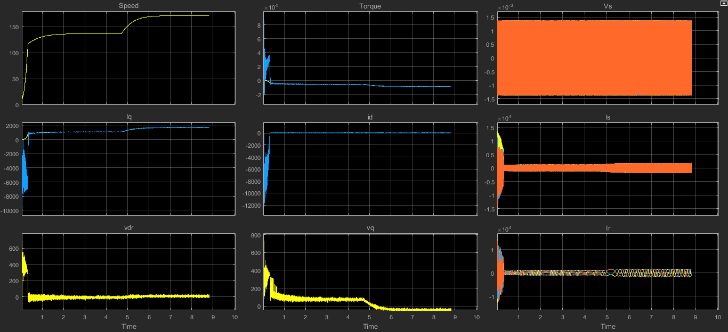

Here we have implemented the simple wind turbine model based on double fed induction generator using MATLAB Simulink.

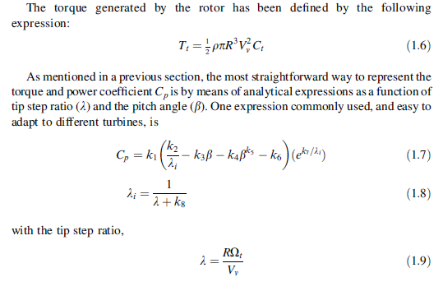



[1]****

****Based on the equations the wind turbine model is implemented in the Simulink. Three blade wind turbine model is also included in the initialization program from which Ct (Torque Coefficient) in the function of Lambda is obtained and is implemented according to this formulae above. The power curve in terms of wind speed is also implemented. Two to four megawatt wind turbine is used here. The wind turbine model is implemented as shown above.

At 8 metre per second wind speed is given first as input. Internally the Lambda is calculated from radio, rotational speed and wind speed. This wind turbine model is referred to the low speed shaft so we have to consider the gearbox ratio. From Lambda we can get Ct with the help of look up tables in the MATLAB. With the Ct and Lambda we have to produce the equation that gives the torque produced by the three blades, and then we divide it by the gearbox ratio to get the actual torque from the wind turbine. The negative sign indicates that the wind turbine is to be operated as a generator convention. The Maximum Power Point Tracking control strategy is now implemented which is indirect speed control and is the most simplest one : First measure the speed of the wind shaft then square the speed , then multiply it by the constant Kopt and lastly the result becomes the torque reference . Since the damping is very small the Dt_m block is not needed here. Kopt is implemented from the formula as shown above. Since it is indirect speed control PI controller is not needed anymore. The inertia is reduced for faster simulation.

At 8 metre per second which is the wind speed: the actual speed (Wm) is increasing. Also we can see how the torque is moving and according to it and iq current is moving as well. There is large oscillations at the torque defaults of the reduced inertia. This speed is the sub synchronous speed and there is negative torque as well. At steady state speed and torque we will verify the power output. We will calculate the power generated at 8 metre per second and 10 metre per second.

P=WT (At 8 metre per second wind speed)

P=136.75*-5600 (from simulation curve)

P=-765800watts

This is the generated power at 8 metre per second which can be verified from the power-wind curve.

At strong wind variation 10 metre per second. We can see how much the speed is increasing and we are moving from sub synchronous speed to hyper synchronous speed. Then the torque is going on down and the speed is going up, thus the generated power should be increasing as well. The id current is controlled to zero and we are magnetising the generator through the stator so we can see Is and Ir .

At 10 metre per second as wind speed:

P=WT

P=171.25*-8700(from simulation)

P= -1489875 watts

The power generated at 10 metre per second can be verified from the power-wind curve.

**MATLAB SIMULATION - III ON GRID CONVERTER IMPLEMENTATION IN WIND TURBINE ON DFIG**

The Simulink model after implementation in the model is as follows:

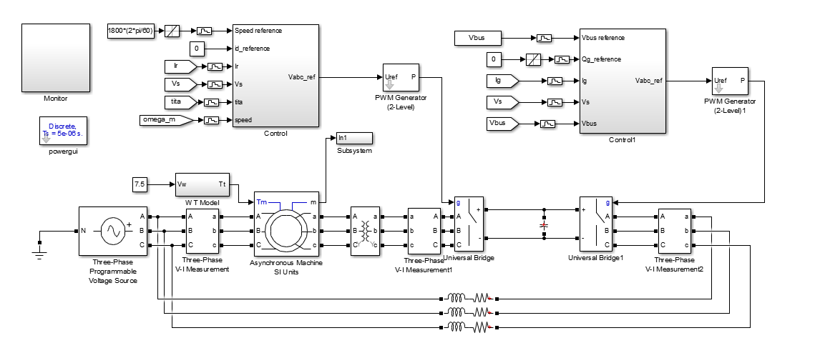

INSIDE THE CONTROL CIRCUIT BLOCK:

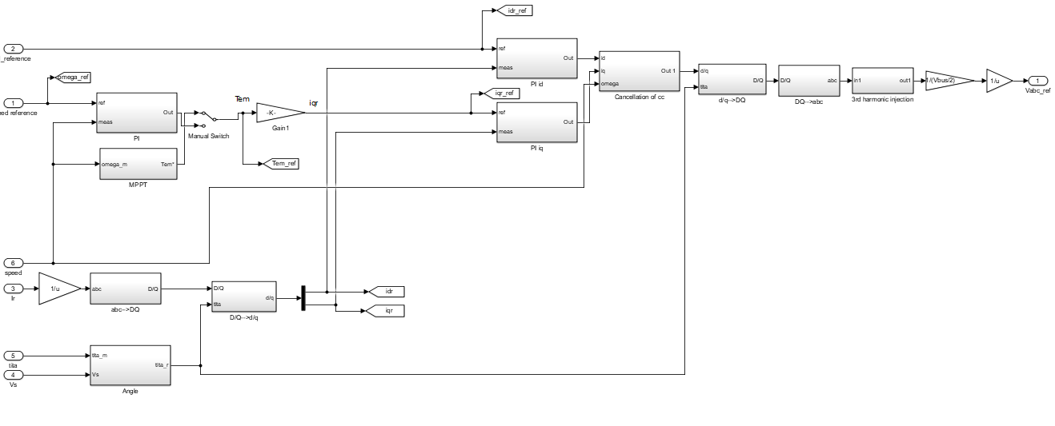

INSIDE THE CONTROL CIRCUIT1 BLOCK:

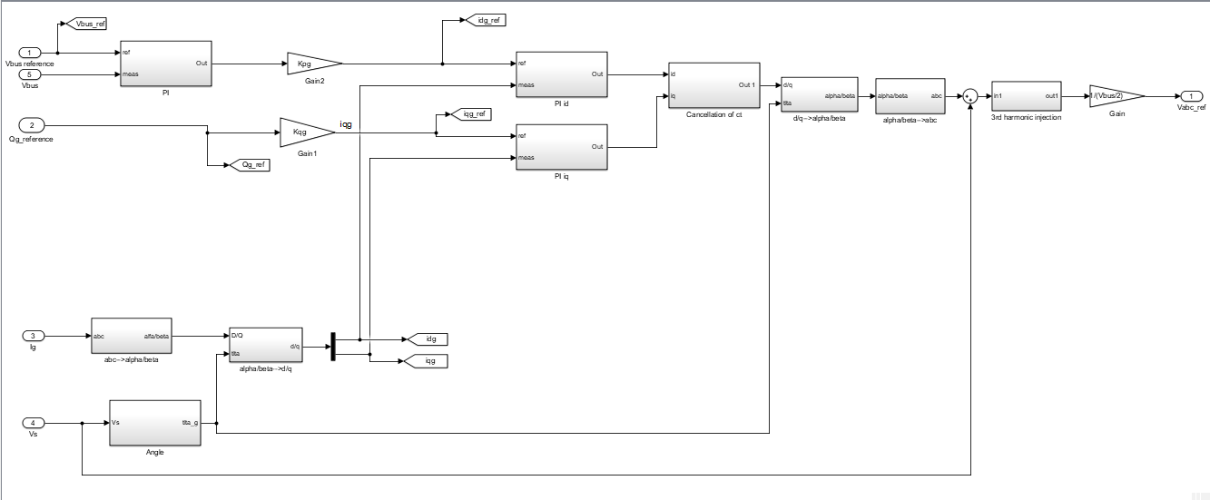

The MATLAB script which is run in editor is given which contains various machine parameters and PID parameters is:

close all

clear all

clc

%% DFIG Parameters -> Rotor parameters referred to the stator side

f = 50; % Stator frequency (Hz)

Ps = 2e6; % Rated stator power (W)

n = 1500; % Rated rotational speed (rev/min)

Vs = 690; % Rated stator voltage (V)

Is = 1760; % Rated stator current (A)

Tem = 12732; %Rated torque (N.m)

p=2; % Pole pair

u = 1/3; % Stator/rotor turns ratio

Vr = 2070; % Rated rotor voltage (non-reached) (V)

smax = 1/3; % Maximum slip

Vr_stator = (Vr*smax)*u; % Rated rotor voltage referred to stator (V)

Rs = 2.6e-3; % Stator resistance (ohm)

Lsi = 0.087e-3; % Leakage inductance (stator and rotor) (H)

Lm = 2.5e-3; % Magnetizing / Mutual inductance (H)

Rr = 2.9e-3; % Rotor resistance referred to stator (ohm)

Ls = Lm + Lsi; % Stator inductance (H)

Lr = Lm + Lsi; % Rotor inductance (H)

Vbus = 1150; % DC de bus voltage referred to stator (V)

sigma = 1 - Lm^2/(Ls*Lr); %

Fs = Vs*sqrt(2/3)/(2*pi*f); % Stator Flux (approx.) (Wb)

%Mechanical Parameters

J = 127/2; % Inertia

D = 1e-3; % Damping

fsw = 4e3; % Switching frequency (Hz)

Ts = 1/fsw/50; % Sample time (sec)

%PI regulators

tau_1 = (sigma*Lr)/Rr;

tau_n = 0.05;

wn1 = 100*(1/tau_1);

wnn = 1/tau_n;

kp_id = (2*wn1*sigma*Lr)-Rr;

kp_iq = kp_id;

ki_id = (wn1^2)*Lr*sigma;

ki_iq = ki_id;

kp_n = (2*wnn*J)/p;

ki_n =((wnn^2)*J)/p;

%Three blade wind turbine model

N=100; % Gearbox ratio

Radio= 42; % Radio

ro =1.225; % Air density

% Cp and Ct curve

beta=0; % Pitch angle

ind2=1;

for lambda=0.1:0.01:11.8

lambdai(ind2)= (1./((1./(lambda-0.02.*beta)+(0.003./(beta^3+1)))));

Cp(ind2)=0.73.*(151./lambdai(ind2)-0.58.*beta-0.002.*beta^2.14-13.2).*(exp(-18.4./lambdai(ind2)));

Ct(ind2)=Cp(ind2)/lambda;

ind2=ind2+1;

end

tab_lambda=[0.1:0.01:11.8];

% Kopt for MPPT

Cp_max = 0.44;

lambda_opt = 7.2;

Kopt = ((0.5*ro*pi*(Radio^5)*Cp_max)/(lambda_opt^3));

% Power curve in function of wind speed

P = 1.0e+06 *[0,0,0,0,0,0,0,0.0472,0.1097,0.1815,0.2568,0.3418, ...

0.4437,0.5642,0.7046,0.8667,1.0518,1.2616,1.4976,1.7613,2.0534,...

2.3513,2.4024,2.4024,2.4024,2.4024,2.4024,2.4024];

V = [0.0000,0.5556,1.1111,1.6667,2.2222,2.7778,3.3333,3.8889,4.4444,...

5.0000,5.5556,6.1111,6.6667,7.2222,7.7778,8.3333,8.8889,9.4444, ...

10.0000,10.5556,11.1111,11.6667,12.2222,12.7778,13.3333,13.8889,...

14.4444,15.0000]

figure

subplot(1,2,1)

plot(tab_lambda,Ct,'linewidth',1.5)

xlabel('lambda','fontsize',14)

ylabel('Ct','fontsize',14)

subplot(1,2,2)

plot(V,P,'linewidth',1.5)

grid

xlabel('Wind speed (m/s)','fontsize',14)

ylabel('Power (W)','fontsize',14)

%Grid side converter

Cbus = 80e-3; %DC bus capacitance

Rg = 20e-6; %Grid side filter's resistance

Lg = 400e-6; %Grid side filter's inductance

Kpg = 1/(1.5*Vs*sqrt(2/3));

Kqg = -Kpg;

% PI regulators

tau_ig = Lg/Rg;

wnig = 60*2*pi;

kp_idg = (2*wnig*Lg)-Rg;

kp_igg = kp_idg;

ki_idg = (wnig^2)*Lg;

ki_iqg = ki_idg;

kp_v = -1000;

ki_v = -300000;

**MATLAB SIMULATION AT WIND SPEED = 7.5 M/S FOR ROTOR SIDE CONTROL**

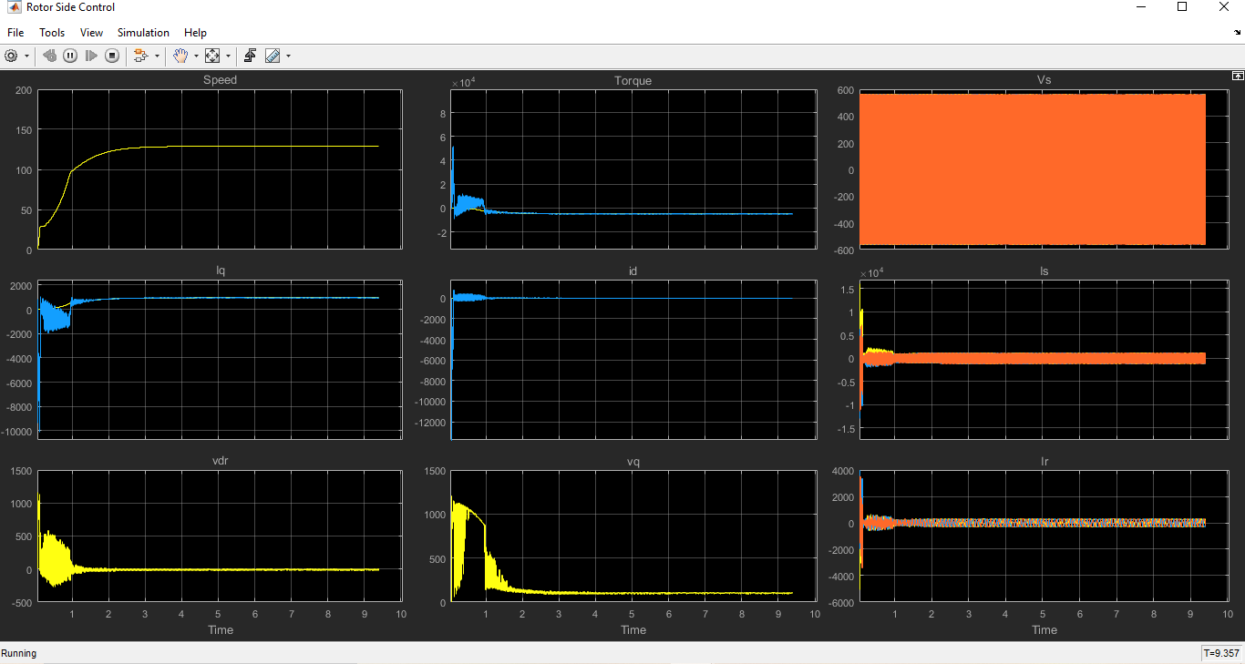

**MATLAB SIMULATION AT WIND SPEED = 7.5 M/S FOR GRID SIDE CONTROL**

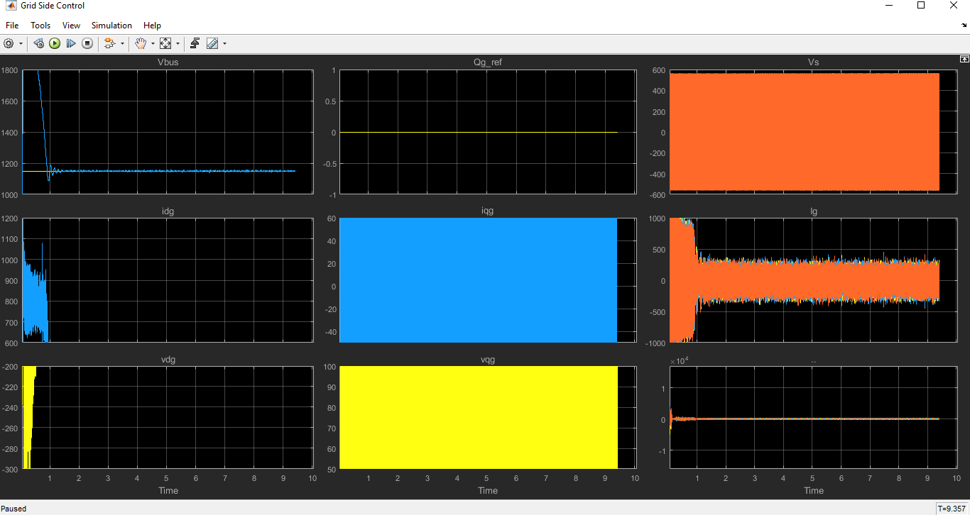

**MATLAB SIMULATION AT WIND SPEED = 11M/S AND OG_REF FROM 0 TO -400E3 FOR ROTOR SIDE CONTROL**

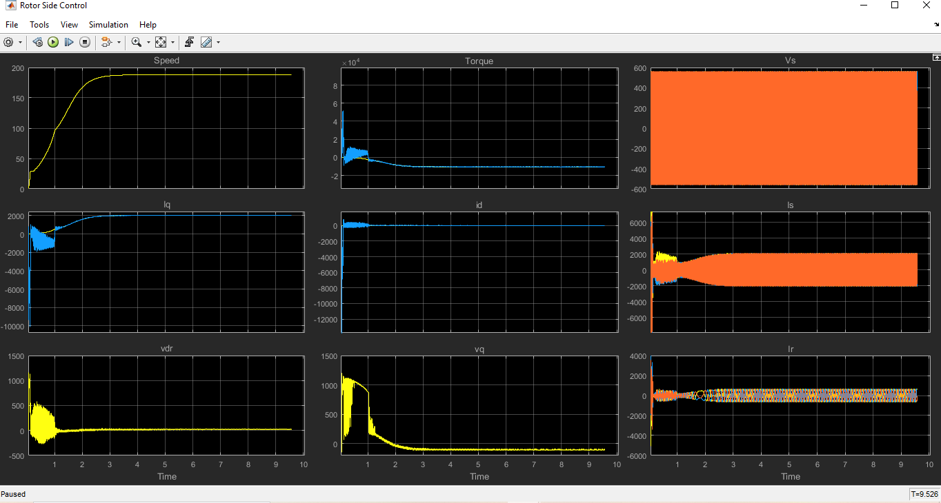

**MATLAB SIMULATION AT WIND SPEED = 11M/S AND OG_REF FROM 0 TO -400E3 FOR GRID SIDE CONTROL**

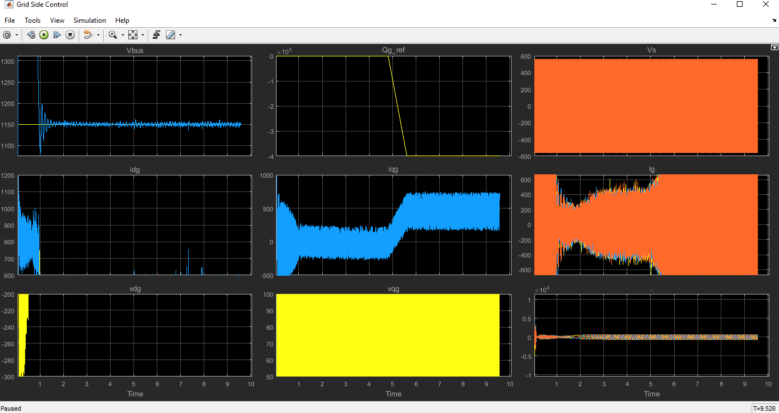

Here we have performed the grid converter implementation in a wind turbine based on DFIG. The grid side control is implemented here, for that purpose a power electronic converter is placed in place of the DC bus voltage source. A DC bus capacitor is present between the two power electronic converters and the capacitors initial voltage is taken to be zero. Three RL filters are used as the grid side filter . All the grid side filter and controller parameters are provided in the initialization program. Another three phase VI measurement instrument is taken and connected to the filter to measure the id current. In order to operate the grid side converter and rotor side converter with real voltages is a transformer is placed in rotor side.

Doubly Fed Induction machine we are using has stator to rotor turns ratio of 1 by 3. The transformer is assumed to be an ideal one and the only effect of this transformer is to implement the stator and voltage rotor voltage relation. The PWM modulator is taken whose initial phase is taken to be zero to eliminate the symmetries that may have crept in the grid side converter. The initial phase of both the PW modulators is taken to be zero. This is the overall power circuit.

The grid side control for the control circuit is implemented here. The grid side voltages and grid side currents are taken and we can control the DC bus voltage and reactive power exchange with the grid. The constant reference voltage of DC bus voltage is taken as Vbus . A rate limited is used at the reactive power reference. The angle theta of the grid voltage is estimated with the help of ABC to alpha/beta transformation and then, with the help of trigonometric block the angle can be calculated. The idg and iqr currents are taken as the reference.

Maximum rotor power will flow from rotor side converter. The P, I, D parameters are already initialised study in the program. The DC bus voltage is controlling the id current. We have the graphs for both the rotor side control and grid side control. The rotor side control, grid side control and the wind turbine all are started simultaneously and the starting is very strong.

* At 7.5 metre per second wind speed there is large overshoot in the DC bus voltage since the start-up we have done is very strong. During the start-up after sometime the rotor side converter and grid side converter reaches a stable operating point. Then the current loop, torque loops in the rotor side control are working properly and so the speed is increasing or moving up as the MPPT is also operating at its optimal condition .At the grid side Vqg is a small since the feedback is employed.
* At 11 metre per second wind speed the MPPT algorithm operates with less torque and higher speed. A perturbance is present in the DC bus voltage. For -400 volt ampere reactive power reference the iq current for the grid side control is also being modified. The rotor side currents are almost constant and we are at hyper synchronous speed. The rotor active power is increasing since we are at hyper synchronous operation and we have reached stable reactive power and current. The rotational speed of shaft is indirectly controlled.

**EMERGING RELIABILITY ISSUES FOR WIND POWER SYSTEM**

[1] The dramatic growth in the total number of installations and of the individual capacity of wind turbines makes their failure harmful or even unacceptable from the TSO point of view. Failures of WTSs will not only cause stability problems for the power grid owing to the sudden absence of large amounts of power, but also result in very high costs for repair and maintenance, especially for those turbines that are large and remote. Therefore, reliability performance is a critical design consideration for the next generation of wind power converter systems.

Unfortunately, former field feedback has shown that the larger wind turbines seem more prone to failure.

[1] It is noted that although the generator and gearbox have the largest downtime (i.e., time needed for repair), their probability of failure is lower than that of the electrical and control parts. Thus, understanding and improving the reliability performance of the power electronic converters will be crucial for wind turbines in the future, especially for the larger ones at multi-MW level.

In order to achieve more cost-efficient and reliable power electronics, multi-disciplines are necessary, which involve stress analysis, strength modelling, statistical considerations and also the online monitoring/control/maintenance of the converter system.

[1] Stress analysis might focus on the complete mission profile definition, converter design and stress estimation and measurement. This group of disciplines will target the accurate determination of the converter’s loading profile, which can trigger failure mechanisms of critical components, such as thermal cycling in power devices, voltage increase in the DC bus, vibration and humidity.

Strength modelling might involve the identification, modelling and accelerating tests of failure mechanisms in the converter system, for example, the bond wire lift-off and soldering cracks inside the power devices. The goal of this group of disciplines is to seek correlations between the established/measured stresses and the quantified fatigues/failures of critical components.

The monitoring and control approach might relate to lifetime monitoring, stress relief controls and intelligent maintenance. This group of disciplines will target the monitoring and control of the converter’s lifetime during operation.

[1] The probability and statistics might add the statistical distribution and correlation to the acquired stress, strength and component configuration. This group of disciplines will target the enhancement of the robustness of the designed converter and take into account the severe usage, as well as quality variations of the components.

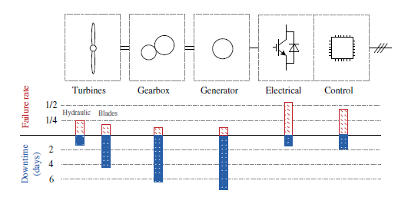

Failure rate and downtime for different parts of wind turbine system

**CONCLUSION**

This report discusses the power electronics used in WTSs. The configurations and roles of power electronics in various wind turbine concepts are illustrated showing that the wind turbine behavior/ performance is significantly improved by introducing power electronics. It is possible for wind turbines to act as an active contributor to the frequency and voltage control in the grid system by means of power control using power electronic converters.

As the WTS capacity and voltage are increasing, a trend is to use multilevel topologies or parallel the converter cells in the wind power converter, and a number of these are shown in this chapter. Different layers of control are discussed, as are the state-of-the-art requirements by grid codes. Finally, the emerging challenges regarding reliability and the approaches for more reliable wind power converters are also highlighted.

**REFERENCES**

[1] Haitham Abu-Rub, Mariusz Malinowski, Kamal Al-Haddad, POWER ELECTRONICS FOR RENEWABLE ENERGY SYSTEMS, TRANSPORTATION AND INDUSTRIALAPPLICATIONS © 2014 John Wiley & Sons Ltd, ISBN 978-1-118-63403-5.

[2] Gonzalo Abad, Jesu´s Lo´pez , Miguel A. , Rodrı´guez , Luis Marroyo , Grzegorz Iwanski, DOUBLY FED INDUCTION MACHINE MODELING AND CONTROL FOR WIND ENERGY GENERATION © 2011 John Wiley & Sons Ltd, ISBN 978-0-470-76865-5.